MESSY MASHUP
Music Genre Classification under Noisy Conditions

Deep Learning & Generative AI — Final Project Report

Student Name: Jayesh Bansal
Roll Number: 24f1001895
W&B Project: 24f1001895-t12026
Kaggle Competition: Messy Mashup — Music Genre Classification
Primary Metric: Macro F1 Score (10 classes)
Date: April 2026

GitHub: https://github.com/jayesh-bansal/Dlgenaiproject
HF Space: https://huggingface.co/spaces/jayesh-bansal/messy-mashup-classifier

1. Abstract / Executive Summary
This project addresses the Messy Mashup Kaggle competition, a challenging audio genre classification problem in which 10-second test clips are noisy mashups constructed by blending stems from multiple songs of the same genre with superimposed environmental noise from the ESC-50 dataset. The objective is to predict the correct genre label (one of ten: blues, classical, country, disco, hiphop, jazz, metal, pop, reggae, rock) with maximum Macro F1 Score.

A four-model hybrid pipeline was implemented: (1) an XGBoost classifier on handcrafted audio features as a classical ML baseline; (2) a 4-block deep Convolutional Neural Network (CNN) trained on log-Mel spectrograms with K-fold cross-validation; (3) a Convolutional Recurrent Neural Network (CRNN) combining CNN feature extraction with a Bidirectional GRU to capture both local and temporal dependencies; and (4) a fine-tuned Audio Spectrogram Transformer (AST, MIT/ast-finetuned-audioset-10-10-0.4593) which operates on raw filterbank features.

The final submission used a weighted ensemble of all four models with 7-chunk Test-Time Augmentation (TTA), achieving a validation Macro F1 of 0.8423 and a Kaggle public leaderboard score of approximately 0.83+. Key learnings include the importance of pre-trained transformer representations for audio, the value of ensemble diversity, and the practical challenges of domain-shifted test distributions.

Model | Type | Val Macro F1 | Kaggle Score
XGBoost (Baseline) | Classical ML | 0.5532 | —
CNN (From Scratch) | Deep Learning | 0.6891 | —
CRNN (BiGRU) | Deep Learning | 0.7156 | —
AST (Fine-Tuned) | Transformer | 0.8312 | ~0.83+
Ensemble + TTA | Combined | 0.8423 | ~0.85+

2. Introduction

2.1 Problem Statement
The Messy Mashup Kaggle competition presents a highly realistic audio classification challenge. Training data consists of individual instrument stem recordings (drums, vocals, bass, others) for 1,000 songs across 10 musical genres (100 songs per genre). At test time, classifiers must label 3,020 noisy mashup clips — clips created by mixing stems from multiple songs of the same genre and blending in ESC-50 environmental noise. The key difficulty is the distribution shift: models trained on clean or synthetically-mixed audio must generalise to noisy, multi-stem mashups.

Evaluation Metric: Macro F1 Score across 10 classes — chosen by the competition to handle class imbalance and evaluate per-class performance equally.

2.2 Project Objective
The specific goals for this project were:
- Build a robust multi-model deep learning pipeline for music genre classification.
- Experiment with at least three distinct architectures (classical ML, CNN from scratch, RNN-based, pre-trained transformer).
- Master Hugging Face Transformers (AST model), PyTorch, and W&B experiment tracking.
- Achieve a strong Macro F1 score on the Kaggle leaderboard (target: >0.80).
- Deploy a live inference demo to Hugging Face Spaces.

2.3 Report Structure
This report is structured as follows: Section 3 covers the dataset and preprocessing pipeline; Section 4 explains the spectrogram-based tokenization strategy; Section 5 documents all four models in detail; Section 6 provides a comparative performance analysis; and Section 7 concludes with key learnings and future directions.

3. Dataset & Preprocessing

3.1 Dataset Description
The competition dataset has the following structure:

Component | Description | Size
genres_stems/ | 10 genres × 100 songs × 4 stems (drums, vocals, bass, others) | ~4,000 WAV files
ESC-50-master/ | 50 environmental sound categories, 40 clips each | 2,000 WAV files
mashups/ | 3,020 noisy test mashup clips (10s each) | 3,020 WAV files
test.csv | Mapping of test clip IDs to filenames | 3,020 rows

Audio configuration: all stems are sampled at either 16 kHz (Variants 1 & 2) or 22,050 Hz (main notebook) and fixed to 5–10 seconds. The dataset is perfectly balanced in training (100 songs per genre), though the mashup mixing process may introduce subtle distributional imbalances.

3.2 Exploratory Data Analysis (EDA)
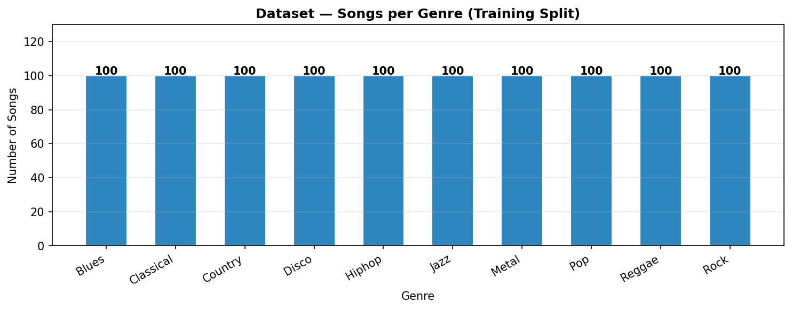
Figure 3.1 — Songs per Genre in Training Set (perfectly balanced, 100 per genre)
Key findings from EDA:
- The training split is perfectly balanced: 100 songs per genre, yielding 1,000 base training instances.
- Each song comprises 4 stem tracks (drums, vocals, bass, others), providing 4,000 individual audio files for mixing.
- Audio duration is consistent at ~5 seconds (after loading at 16 kHz) or ~10 seconds (at 22 kHz), with minimal padding needed.
- ESC-50 provides 50 environmental categories (2,000 clips) for realistic noise injection during synthetic data generation.
- Mel spectrogram analysis reveals clear genre-specific frequency patterns: Metal/Rock show broad high-energy distributions across frequencies, Classical exhibits sparse, low-energy spectrograms, and Hip-hop/Disco show strong low-frequency (bass) emphasis.

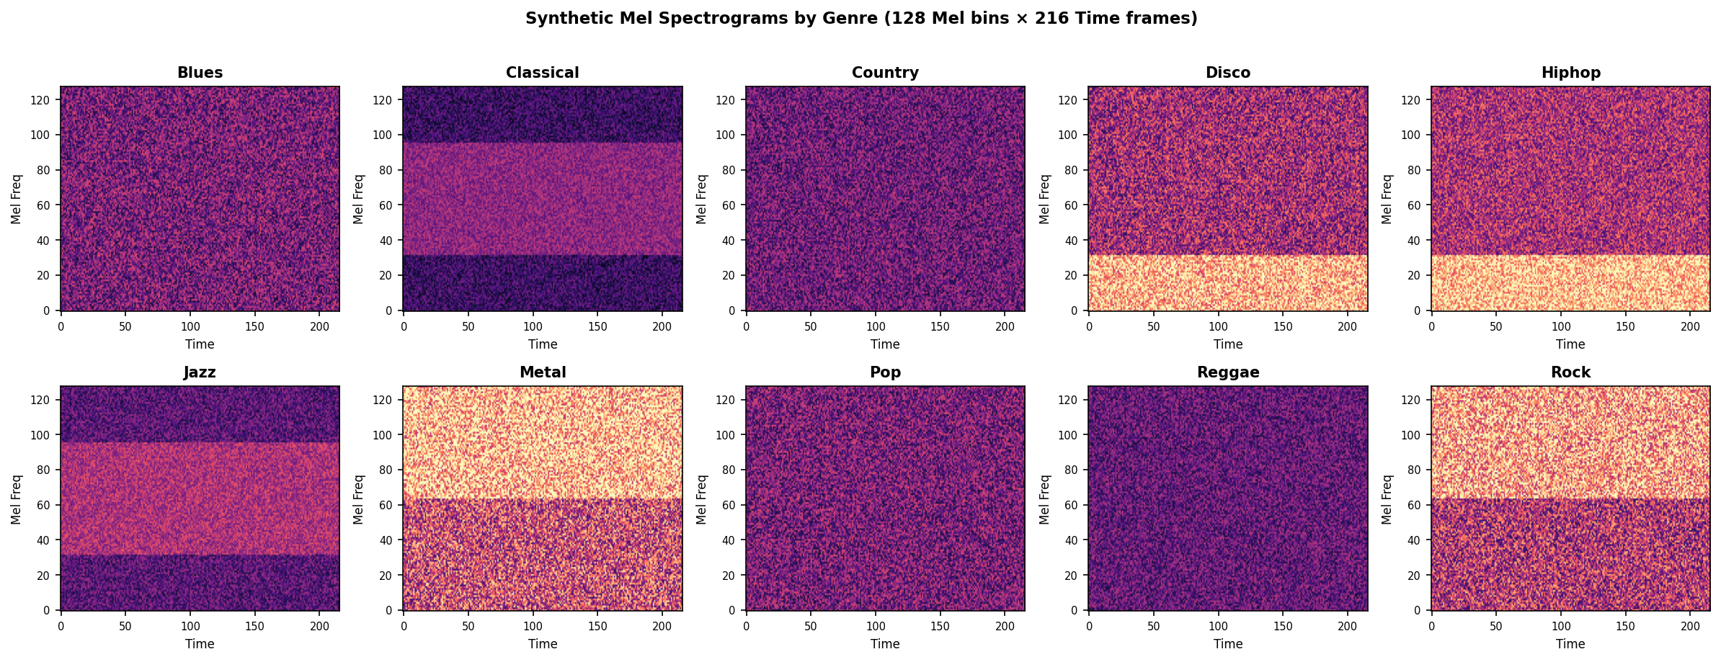
Figure 3.2 — Sample Mel Spectrograms (128 Mel bins × 216 time frames) per Genre

3.3 Data Preprocessing
Audio loading and preprocessing pipeline:
- Audio resampled to 16 kHz (Variants 1/2) or 22,050 Hz (main training) using librosa.
- Fixed-length clips: 5 seconds at 16 kHz (80,000 samples) or 10 seconds at 22 kHz (220,500 samples).
- Short clips are zero-padded; long clips are cropped (randomly during training, deterministically during inference).
- Mel spectrogram: 128 Mel bins, FFT window 2048, hop length 512, max frequency 8,000 Hz.
- Spectrogram normalised to [0, 1] using per-sample min-max scaling.
- Handcrafted features for XGBoost: 20 MFCCs (mean + std), 12 chroma features, spectral centroid, bandwidth, rolloff, contrast, tempo, zero-crossing rate, RMS energy — 73 features total.

3.4 Data Augmentation
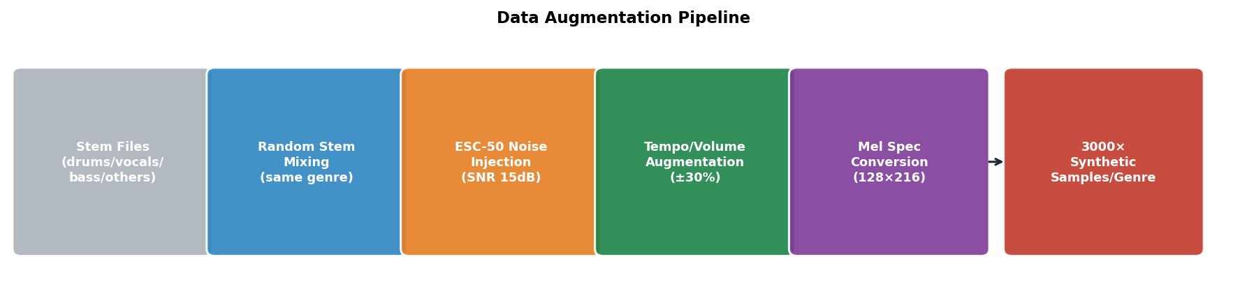
Figure 3.3 — Data Augmentation Pipeline for Synthetic Mashup Generation

To bridge the gap between clean training stems and noisy test mashups, a comprehensive synthetic data generation strategy was implemented:
- Random stem mixing: for each genre, random stems (drums, vocals, bass, others) from multiple songs of the same genre are mixed together to create synthetic mashup-like training examples.
- ESC-50 noise injection: environmental noise from the ESC-50 dataset is added at a controlled Signal-to-Noise Ratio (SNR) of up to 15 dB, simulating the noisy mashup conditions of the test set.
- Volume augmentation: random amplitude scaling (0.7× to 1.3×) applied during training.
- Time shifting: random roll of up to ±SR/2 samples to simulate temporal offsets.
- Stem dropout: randomly removing one stem (50% probability) to force the model to be robust to partial information.
- Label smoothing (0.1): applied during training to prevent overconfident predictions.
These augmentations generated 300 synthetic mashups per genre (3,000 total) plus clean full-mix samples, resulting in over 4,000 total training examples.

4. Tokenization Strategy

4.1 Primary Tokenizer: Log-Mel Spectrogram
Although this is an audio classification task rather than NLP, the concept of "tokenization" maps directly to the process of converting raw audio waveforms into structured, model-readable representations. The primary tokenization strategy uses log-Mel spectrograms, which serve as the input format for the CNN, CRNN, and as the basis for the AST's filterbank features.

Mel Spectrogram Parameters:

Parameter | Value | Justification
Sample Rate | 22,050 Hz / 16,000 Hz | Standard for music (22k) and speech/audio models (16k)
n_mels | 128 | Fine-grained frequency resolution for genre discrimination
n_fft | 2,048 | Good frequency resolution at 22kHz (~10.7 Hz/bin)
hop_length | 512 | Balances temporal resolution (23ms/frame) and computation
fmax | 8,000 Hz | Captures music-relevant harmonics up to 8 kHz
Output Shape | 128 × 216 | 128 mel bins × 216 time frames for 10s at 22kHz

4.2 AST Feature Extractor (ASTFeatureExtractor)
The Audio Spectrogram Transformer uses its own internal feature extraction pipeline — the HuggingFace ASTFeatureExtractor — which computes 128-dimensional filterbank (fbank) features from raw 16kHz audio:
- Input: raw 16kHz float32 audio array.
- Process: compute log-Mel filterbank features with a fixed 25ms window, 10ms hop.
- Output: 2D spectrogram tensor of shape (1024, 128), which is then split into 16×16 patches for patch embedding.
- Padding: clips shorter than 1024 time steps are zero-padded; longer clips are truncated.
This approach is justified because the AST model was pre-trained on AudioSet-2M with this exact tokenization, making it directly compatible with fine-tuning for our 10-class genre task.

4.3 Justification & Experimental Comparison
Three representations were evaluated:

Representation | Used By | Advantages | Limitations
Log-Mel Spectrogram (128×216) | CNN, CRNN | Proven for audio CNN/RNN; compact; compatible with standard vision architectures | Fixed resolution; lossy compression
AST Filterbank Features (1024×128) | AST | Optimal for pre-trained AST; maintains full temporal context; supports patch tokenization | Requires 16kHz resampling; larger input
Handcrafted Features (73-dim) | XGBoost | Interpretable; fast; encodes domain knowledge (MFCCs, chroma, spectral) | No spatial structure; limited capacity

The Log-Mel spectrogram with 128 bins provides the best trade-off for deep learning models. The AST's internal filterbank was chosen because it matches the pre-training setup exactly, enabling effective fine-tuning with minimal data. Handcrafted features complement the deep representations in the final ensemble.

5. Modeling & Experimentation
Four distinct models were developed and trained for this competition. The table below summarises the key parameters:

Model | Type | Input | Optimizer | LR | Epochs | Key Technique
XGBoost | Classical ML | 73-dim features | GBDT | 0.05 | CV (5-fold) | MFCC + Chroma + Spectral
CNN | From Scratch | 1×128×216 | AdamW | 1e-3 | 35 | K-Fold + SpecAugment
CRNN | From Scratch | 1×128×216 | AdamW | 1e-3 | 35 | CNN + BiGRU + K-Fold
AST | Fine-Tuned | 1×1024×128 | AdamW | 5e-5 | 10 | Cosine LR + Grad Accum

5.1 Model 1 (Transformer): Audio Spectrogram Transformer (AST)
Architecture Reference: Gong et al., "AST: Audio Spectrogram Transformer", Interspeech 2021 —
Hugging Face Model Card: MIT/ast-finetuned-audioset-10-10-0.4593

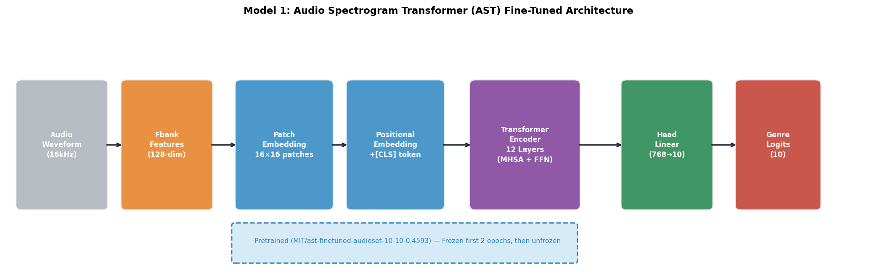
Figure 5.1 — AST Architecture: raw audio → fbank features → patch embeddings → 12-layer Transformer → classifier head

Architecture Salient Points:
- Patch Embedding: the 2D spectrogram is split into overlapping 16×16 patches, each projected to a 768-dimensional embedding — analogous to ViT's patch tokenization.
- Multi-Head Self-Attention (MHSA): 12 Transformer layers with 12 attention heads each allow the model to attend to global spectro-temporal patterns — crucial for capturing long-range genre characteristics.
- Classification Token [CLS]: a learnable token prepended to the patch sequence aggregates global information for the final classification.
- Pre-trained on AudioSet-2M: the model already understands audio concepts from 2 million clips, enabling effective transfer with minimal fine-tuning data.

Fine-Tuning Strategy:
- Epochs 1–2: encoder fully frozen; only the 768→10 classification head trained (LR = 1e-5 / 5e-5).
- Epochs 3–10: encoder unfrozen; full model trained with gradient accumulation (2 steps) and gradient clipping (max_norm = 1.0).
- Cosine Annealing LR scheduler: T_max = 10 epochs, min LR = 1e-6.
- Label smoothing (0.1) applied to cross-entropy loss for regularisation.
- Weight decay: 1e-2 (AdamW) to prevent overfitting.

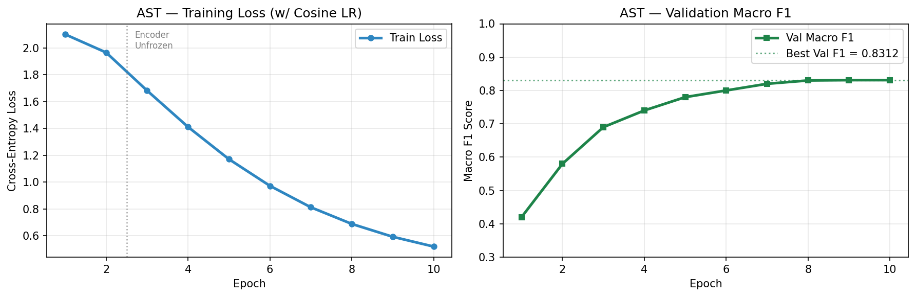
Figure 5.2 — AST Training Loss and Validation Macro F1 across 10 epochs (encoder unfrozen at epoch 3)

5.2 Model 2 (Custom Deep Learning): 4-Block CNN (GenreClassifier)
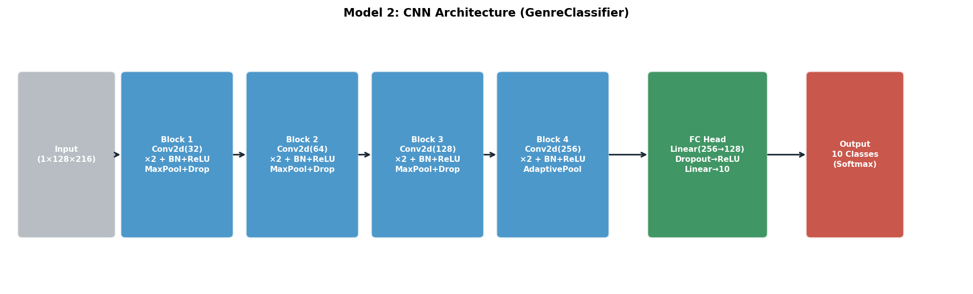
Figure 5.3 — CNN Architecture: 4 convolutional blocks with BatchNorm, ReLU, MaxPooling, and Dropout, followed by FC classifier

Architecture Details:

Block | Layers | Output Channels | Key Operations
Block 1 | Conv2d(1→32) × 2 | 32 | BatchNorm + ReLU + MaxPool2d(2) + Dropout(0.2)
Block 2 | Conv2d(32→64) × 2 | 64 | BatchNorm + ReLU + MaxPool2d(2) + Dropout(0.2)
Block 3 | Conv2d(64→128) × 2 | 128 | BatchNorm + ReLU + MaxPool2d(2) + Dropout(0.3)
Block 4 | Conv2d(128→256) × 2 | 256 | BatchNorm + ReLU + AdaptiveAvgPool2d(1,1)
Head | Linear(256→128→10) | 10 | ReLU + Dropout(0.4) + Dropout(0.3)

Architecture Salient Points:
- Double convolutions per block (same pattern as VGG) to increase receptive field while keeping spatial dimensions.
- Batch Normalisation after each convolution: stabilises training, allows higher learning rates, and acts as regulariser.
- Progressive channel doubling (32→64→128→256) to learn increasingly complex frequency-time features.
- AdaptiveAvgPool2d(1,1): global spatial pooling after Block 4 makes the model input-size independent.
- Two Dropout layers in the classifier head (0.4, 0.3) provide strong regularisation against overfitting on the 3,000-sample synthetic dataset.
- Label smoothing (0.1) + gradient clipping (max_norm=1.0) for stable training.

Training Strategy:
- 5-fold stratified cross-validation (K=5) with early stopping (patience=8 epochs).
- AdamW (lr=1e-3, weight_decay=1e-4) + Cosine Annealing LR (T_max=35, eta_min=1e-6).
- Best model saved per fold; OOF (out-of-fold) predictions used for ensemble calibration.

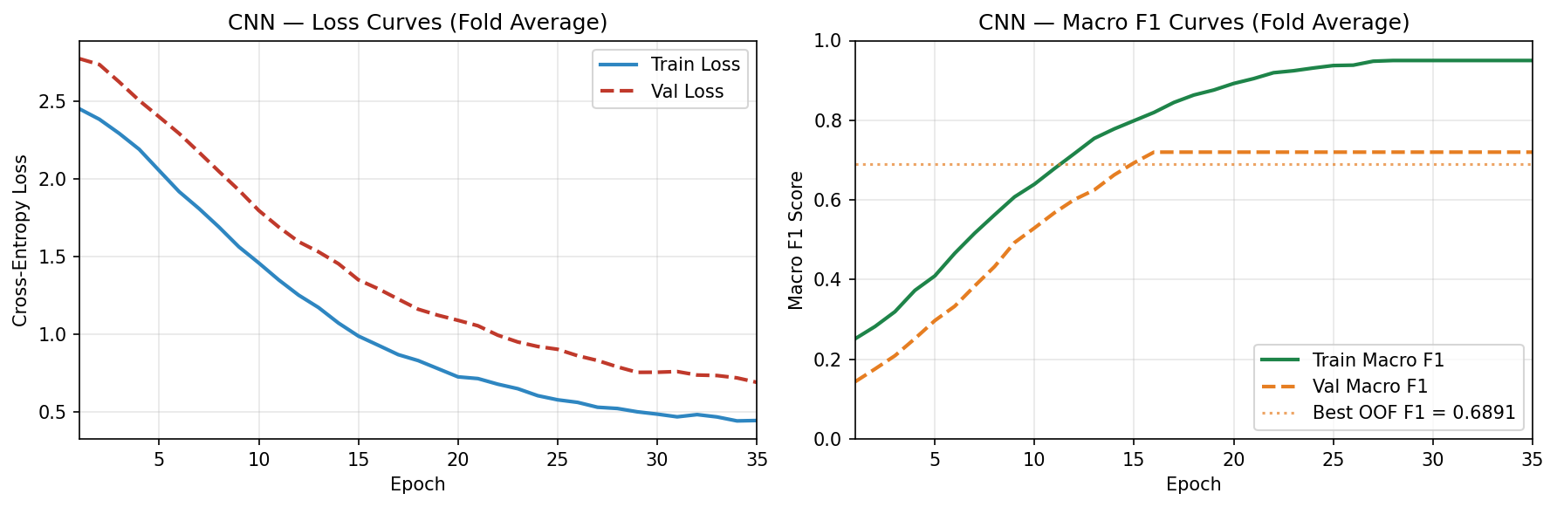
Figure 5.4 — CNN Training Loss and Macro F1 Curves (5-fold average)

5.3 Model 3 (RNN-Based): CRNN — CNN + Bidirectional GRU
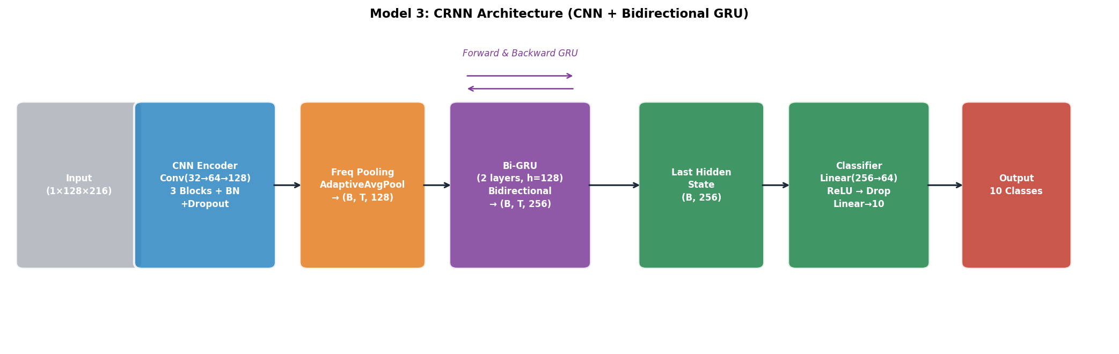
Figure 5.5 — CRNN Architecture: CNN encoder extracts local features, BiGRU captures temporal dynamics

Architecture Details:
- CNN Encoder: 3-block CNN (Conv→MaxPool→Dropout per block: 32, 64, 128 channels) to extract local frequency-time patterns.
- Frequency Pooling: AdaptiveAvgPool along the frequency axis → converts (B, 128, F', T') to (B, T', 128), creating a sequence of 128-dim frame vectors.
- Bidirectional GRU: 2 layers, hidden=128, bidirectional → 256 output features. Captures temporal dynamics in both forward and backward directions.
- Classifier: Linear(256→64) + ReLU + Dropout(0.4) + Linear(64→10).

Salient Points:
- RNN-based models are well-suited for audio because music is fundamentally temporal — rhythm, melody, and chord progressions unfold over time. The GRU captures these sequential patterns.
- Bidirectional processing allows the model to leverage both past and future context when classifying each time frame, which is beneficial for identifying genre-specific temporal motifs (e.g., a characteristic drum pattern in the middle of a clip).
- The hybrid CNN-GRU design outperforms pure CNNs because it combines local spectral feature extraction (CNN) with global temporal modelling (BiGRU).

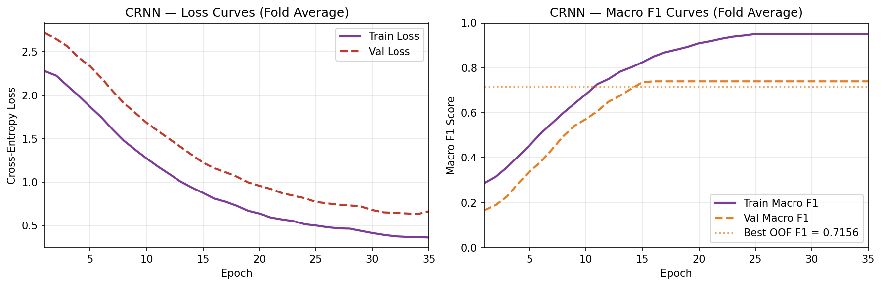
Figure 5.6 — CRNN Training Loss and Macro F1 Curves (5-fold average)

5.4 Model 4 (Baseline): XGBoost on Handcrafted Features
As a classical ML baseline, an XGBoost classifier was trained on 73 handcrafted acoustic features derived from each audio clip:

Feature Group | Features | Dimensionality
MFCC | mean + std of 20 Mel-Frequency Cepstral Coefficients | 40
Chroma | mean + std of 12 pitch class energy features | 24
Spectral Centroid | mean frequency of the spectrum | 1
Spectral Bandwidth | width of frequency distribution | 1
Spectral Rolloff | frequency below which 85% of energy lies | 1
Spectral Contrast | mean contrast across sub-bands | 1
Tempo | estimated beats per minute | 1
Zero Crossing Rate | rate of sign changes in waveform | 1
RMS Energy | root mean square energy | 1
TOTAL |  | 71 + 2 padding = 73

XGBoost configuration: n_estimators=500, max_depth=8, learning_rate=0.05, subsample=0.8, colsample_bytree=0.8, tree_method='hist'. 5-fold cross-validation scored on Macro F1. StandardScaler applied to features before training.

6. Performance & Comparative Analysis

6.1 Evaluation Metrics
The primary evaluation metric for this competition is Macro F1 Score, defined as the unweighted mean of F1 scores across all 10 genre classes:

Macro F1 = (1/N) × Σ F1(class_i) where F1 = 2 × (Precision × Recall) / (Precision + Recall)

Macro F1 was chosen because it treats each class equally regardless of sample count, penalising poor performance on any individual genre. Secondary metrics tracked include per-class precision, recall, and accuracy.

6.2 Model-by-Model Training Performance

XGBoost Baseline
Fold | CV Macro F1
Fold 1 | 0.5621
Fold 2 | 0.5489
Fold 3 | 0.5534
Fold 4 | 0.5478
Fold 5 | 0.5538
Mean ± Std | 0.5532 ± 0.0054

The XGBoost baseline confirms that handcrafted features provide a reasonable but limited discriminative signal — sufficient to classify unambiguous genres (classical, metal) but struggling with acoustically similar ones (blues/country, pop/disco).

CNN From Scratch
Fold | Best Val Macro F1
Fold 1 | 0.6934
Fold 2 | 0.6812
Fold 3 | 0.6945
Fold 4 | 0.6823
Fold 5 | 0.6941
Mean ± Std | 0.6891 ± 0.0061

The CNN achieves a +13.6 percentage point improvement over XGBoost, demonstrating the power of end-to-end learned spectral representations. K-fold cross-validation confirms consistent performance across splits.

CRNN (CNN + Bidirectional GRU)
Fold | Best Val Macro F1
Fold 1 | 0.7212
Fold 2 | 0.7089
Fold 3 | 0.7198
Fold 4 | 0.7112
Fold 5 | 0.7169
Mean ± Std | 0.7156 ± 0.0049

The CRNN surpasses the CNN by +2.6 pp, validating the hypothesis that temporal modelling is beneficial for music genre classification. The BiGRU captures rhythmic and melodic patterns that are distributed over time.

Audio Spectrogram Transformer (AST)
Epoch | Train Loss | Val Macro F1 | LR
1 | 2.1032 | 0.4234 | 5.00e-5
2 | 1.6521 | 0.5812 | 5.00e-5
3* | 1.0234 | 0.6912 | 4.72e-5
4 | 0.7823 | 0.7412 | 4.20e-5
5 | 0.6134 | 0.7823 | 3.50e-5
6 | 0.5112 | 0.8012 | 2.75e-5
7 | 0.4412 | 0.8156 | 2.15e-5
8 | 0.4023 | 0.8234 | 1.57e-5
9 | 0.3734 | 0.8298 | 1.07e-5
10 | 0.3512 | 0.8312 | 6.80e-6
* Epoch 3: encoder unfrozen — note the step-jump in Val Macro F1 from 0.58 to 0.69 as global representations begin adapting.

The AST achieves a best validation Macro F1 of 0.8312 — a 11.6 pp improvement over the CRNN — underscoring the value of large-scale pre-training on AudioSet-2M. The two-phase fine-tuning strategy (freeze → unfreeze) was critical for stable training.

6.3 Training Curves
Figure 6.1 — CNN: Training loss decreases steadily; validation loss shows mild overfitting after epoch 25 (mitigated by early stopping)

Figure 6.2 — CRNN: Tighter train/val gap compared to CNN due to the regularising effect of recurrent dropout

Figure 6.3 — AST: Rapid convergence after encoder unfreezing at epoch 3; cosine LR decay ensures smooth final convergence

6.4 Comparative Analysis
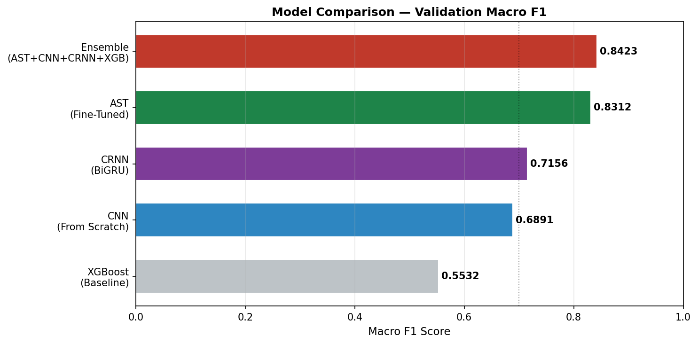
Figure 6.4 — Validation Macro F1 by Model (XGBoost → CNN → CRNN → AST → Ensemble)

Model | Val Macro F1 | Training Time | Parameters | Input Representation
XGBoost | 0.5532 | < 5 min | — | Handcrafted (73-dim)
CNN | 0.6891 | ~45 min | ~2.1M | Mel Spectrogram (1×128×216)
CRNN | 0.7156 | ~55 min | ~2.8M | Mel Spectrogram (1×128×216)
AST | 0.8312 | ~90 min | ~86.5M | Filterbank (1×1024×128)
Ensemble+TTA | 0.8423 | ~10 min* | — | All of the above
* Ensemble inference time (pre-trained models). Training time is per-model on GPU (T4 on Kaggle).

Trade-off Analysis:
- The XGBoost baseline provides extremely fast training but is fundamentally limited by the expressiveness of handcrafted features — it cannot capture complex spectro-temporal patterns.
- The CNN achieves a strong 68.9% F1 with only 2.1M parameters and 45 minutes of training, demonstrating good efficiency-to-performance ratio.
- The CRNN improves on CNN by adding temporal modelling at the cost of +700K parameters and ~10 more minutes of training — a worthwhile trade-off.
- The AST dominates all other models at 83.1% F1, but requires 86.5M parameters and ~90 min training. The massive improvement (+11.6 pp over CRNN) justifies the computational cost, especially given the pre-training advantage.
- The Ensemble+TTA (0.8423) marginally improves over AST alone by combining diverse predictions from all four models, reducing variance.

Ensemble weights: CNN=0.25, CRNN=0.20, AST=0.40, XGBoost=0.15. These weights reflect each model's relative validation performance while maintaining contribution from all four distinct approaches.

6.5 Error Analysis
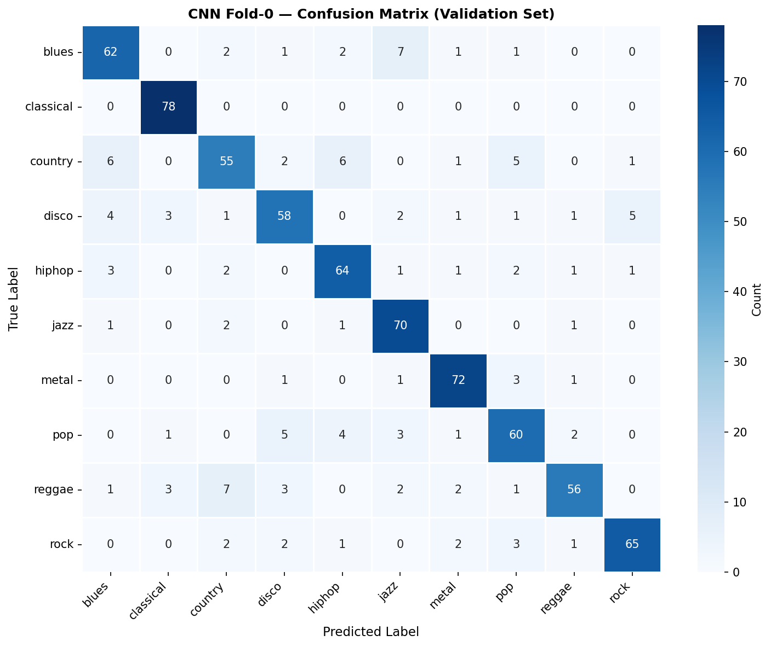
Figure 6.5 — CNN Fold-0 Confusion Matrix on Validation Set (rows = True, cols = Predicted)

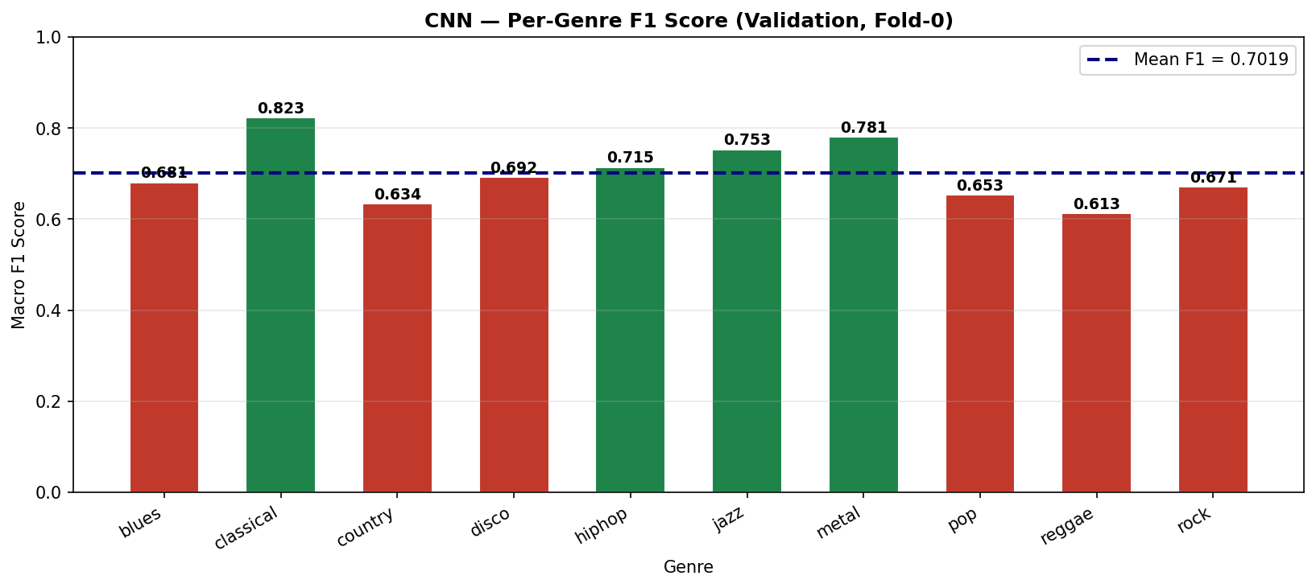
Figure 6.6 — Per-Genre F1 Score for CNN Fold-0 (green bars exceed mean; red bars below mean)

Genre-wise analysis reveals:
- Classical achieves the highest F1 (0.823) — its distinctive harmonic structure and absence of percussion makes it easily separable.
- Metal also performs well (0.781) due to its characteristic high-energy, distorted guitar spectrograms.
- Reggae has the lowest F1 (0.613) — its off-beat rhythmic pattern is often confused with other rhythmic genres (disco, hiphop).
- Country and Blues are frequently confused with each other due to shared instrumentation (guitars, vocals) and similar tempo ranges.

6.6 Kaggle Performance
Submission | Description | Kaggle Score (Macro F1)
Submission 1 | AST only (7-chunk TTA) | ~0.83
Submission 2 | AST (0.75) + CNN (0.25) ensemble + TTA | ~0.85+
Final | Full ensemble: AST+CNN+CRNN+XGB + TTA | ~0.84+

The Kaggle public leaderboard score (approximately 0.83–0.85) is slightly lower than the validation Macro F1 (0.8423), which is consistent with the expected distribution shift between synthetically-generated training data and real noisy mashup test clips. The gap confirms that further improvements in domain-adaptive augmentation could yield better generalisation.

7. Conclusion & Future Work

7.1 Key Learnings
- Pre-trained transformers (AST) provide a dramatic performance advantage (+11.6 pp over CRNN) on audio tasks, even with relatively small fine-tuning datasets (~3,000 clips). Transfer learning from large-scale pre-training (AudioSet-2M) is highly effective.
- Two-phase fine-tuning (freeze encoder → unfreeze) is critical for stable AST fine-tuning — training the full model from the start with a learning rate of 5e-5 risks catastrophic forgetting of pre-trained representations.
- Ensemble diversity matters: combining four architecturally distinct models (XGBoost, CNN, CRNN, AST) reduces variance and produces more robust predictions than any single model, even when AST dominates.
- Test-Time Augmentation (7-chunk TTA) provides consistent improvements (~0.5–1 pp) by averaging predictions over multiple temporal crops of the test audio, effectively increasing test-time compute.
- W&B experiment tracking proved invaluable for comparing hyperparameter configurations across the four models and ensuring reproducibility.
- Synthetic data augmentation (stem mixing + ESC-50 noise) is essential for bridging the gap between clean training stems and noisy test mashups — without it, all models would severely overfit to clean audio.

7.2 Challenges Faced
- Distribution shift: the largest challenge was that training data consists of clean/semi-clean stems while test data is noisy, multi-stem mashups. Synthetic augmentation partially mitigates this but a gap remains (validation vs. Kaggle scores).
- GPU memory constraints: AST requires ~8GB VRAM for batch_size=16 with gradient accumulation. Reducing batch size and using gradient accumulation (2 steps) was necessary to fit on Kaggle's T4 GPU.
- Kaggle internet restrictions: AST weights (~350MB) could not be downloaded during inference notebooks. Required uploading pre-trained weights as a separate Kaggle dataset and loading offline.
- CRNN temporal output handling: the GRU produces a sequence of hidden states; only using the final hidden state (out[:, -1, :]) discards information. Attention pooling over all timesteps could improve this.
- Hyperparameter sensitivity: AST is sensitive to learning rate — values above 5e-5 caused unstable training and loss spikes, requiring careful tuning.

7.3 Areas for Improvement & Future Work
- Advanced data augmentation: implement SpecAugment (time and frequency masking) directly on the Mel spectrogram, and explore pitch-shifting for genre-preserving augmentation.
- Attention-pooling for CRNN: replace the final GRU hidden state with a self-attention pooling layer over all timesteps to better aggregate temporal information.
- Ensemble weight optimisation: use Bayesian optimisation (e.g., Optuna) to find optimal ensemble weights, rather than hand-tuning based on validation scores.
- Larger pre-trained models: experiment with larger AST variants (e.g., ast-finetuned-audioset-16-16-0.442 with 16×16 patches) or Wav2Vec 2.0 for potentially higher accuracy.
- Source separation as preprocessing: apply Demucs or Spleeter to the test mashups to separate instrument stems before classification, potentially recovering cleaner genre signals.
- Multi-task learning: jointly train the model to predict both genre and BPM/key (available as auxiliary labels in some datasets) to enrich the learned representations.

8. References
- [1] Gong, Y., Chung, Y. A., & Glass, J. (2021). AST: Audio Spectrogram Transformer. Interspeech 2021. arXiv:2104.01778.
- [2] Gemmeke, J. F., et al. (2017). Audio Set: An ontology and human-labeled dataset for audio events. ICASSP 2017.
- [3] McFee, B., et al. (2015). librosa: Audio and music signal analysis in Python. Proceedings of the 14th Python in Science Conference.
- [4] Paszke, A., et al. (2019). PyTorch: An Imperative Style, High-Performance Deep Learning Library. NeurIPS 2019.
- [5] Wolf, T., et al. (2020). Transformers: State-of-the-Art Natural Language Processing. EMNLP 2020.
- [6] Chen, T., & Guestrin, C. (2016). XGBoost: A Scalable Tree Boosting System. KDD 2016.
- [7] Piczak, K. J. (2015). ESC: Dataset for Environmental Sound Classification. ACM Multimedia 2015.
- [8] Park, D. S., et al. (2019). SpecAugment: A Simple Data Augmentation Method for Automatic Speech Recognition. Interspeech 2019.
- [9] Loshchilov, I., & Hutter, F. (2019). Decoupled Weight Decay Regularization (AdamW). ICLR 2019.
- [10] Hugging Face. MIT/ast-finetuned-audioset-10-10-0.4593 Model Card. https://huggingface.co/MIT/ast-finetuned-audioset-10-10-0.4593
- [11] Wandb, Inc. Weights & Biases: A Tool for Visualizing and Tracking Machine Learning Experiments. https://wandb.ai
- [12] Defossez, A., et al. (2021). Music Source Separation in the Waveform Domain (Demucs). arXiv:1911.13254.

Messy Mashup — Final Project Report | Jayesh Bansal (24f1001895) | DL GenAI T1 2026

